Setup PlayWright:

Prerequisite:

* Node.js is installed (https://www.nodejs.org)
* Terminal (Mac) or Command line (Windows) is used

Install Playwright into Project directory:

* Setup a folder/directory where you want your tests in (C:/{test_folder} for Windows or /Users/{username}/{test_folder} for Mac)
* In the terminal, change directory to the test folder (cd /Users/{username}/{test_folder})
* Enter **npm init playwright@latest**
* Install the listed following packages (E.g. At this time, its [create-playwright@1.17.135](mailto:create-playwright@1.17.135))
* Do you want to use Typescript or Javascript? Select one (For this setup, Javascript is selected)
* Where to put your end-to-end tests? Name your folder anything. Press enter/return key for the default name “tests”
* Add a GitHub Actions workflow? Can make any selection
* Install Playwright browsers (can be done manually via 'npx playwright install')? Press enter
* Verify Playwright installation was successful

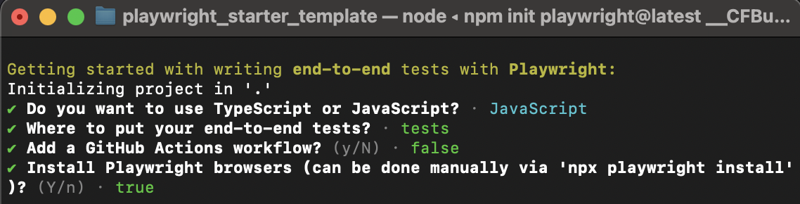

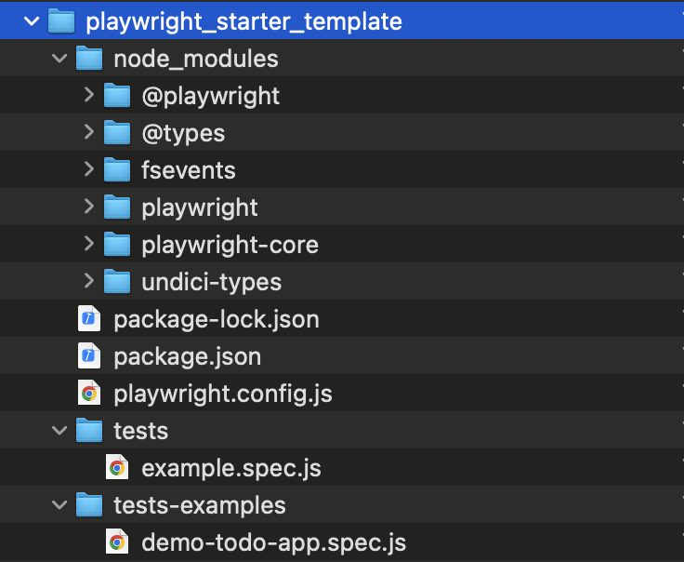

Run the Basic Test

* In the Terminal, enter **npx playright test**
* Verify the tests pass
* Run the report and view the results

Run the Basic Test in User Interface (UI)

* In the Terminal, enter **npx playright test --ui**
* Verify the UI is displayed on screen (Insert image)

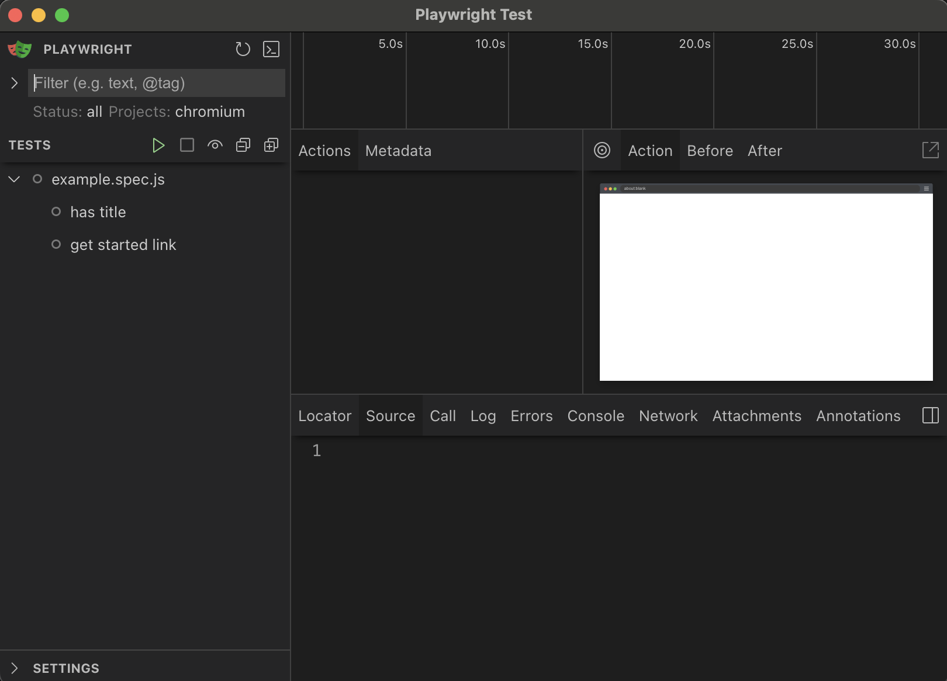

* In the Tests tree on the left side of the UI, select the Play icon (green triangle)
* Verify the tests run and pass
* Click on each item in the example.spec.js tree

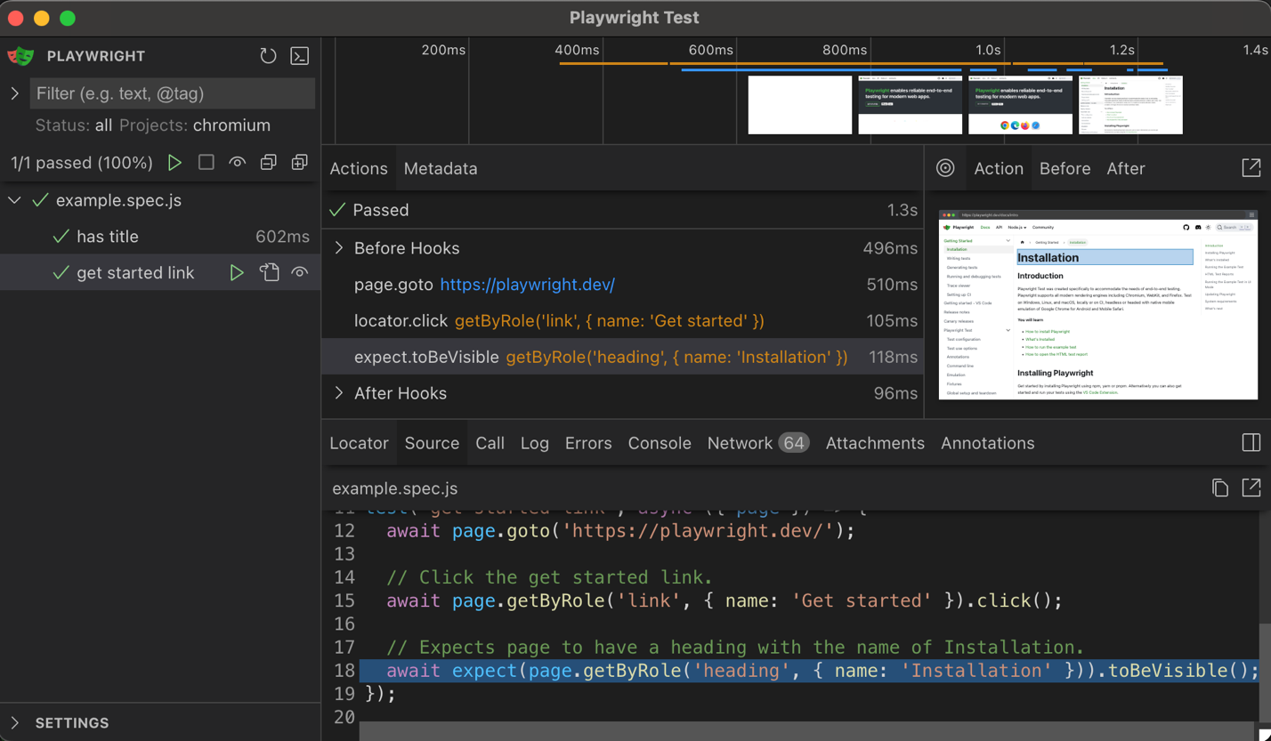

* Close the UI when finished